Name | NHS Scotland
Photo | 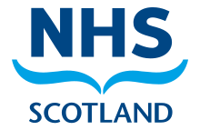
Established | 5 July 1948
Country | Scotland
Health Boards | 14
Backstory | NHS Scotland has health records concerning anyone born in Scotland or who has visited a GP, Hospital or Dentist in Scotland.  It has records concerning Maria’s medical history in Scotland.
Role | Regulator
Story

